**Sourcecode:**

**package** com.simplilearn.demo;

**import** org.openqa.selenium.By;

**import** org.openqa.selenium.WebDriver;

**import** org.openqa.selenium.WebElement;

**import** org.openqa.selenium.chrome.ChromeDriver;

**import** org.openqa.selenium.support.ui.Select;

**public** **class** OracleRegistration {

**public** **static** **void** main(String[] args) {

System.*setProperty*("webdriver.chrome.driver","F:\\Simplilearn Bootcamp\\Phase 5\\chromedriver_win32\\chromedriver.exe");

//step:2 initializing chrome

WebDriver driver= **new** ChromeDriver();

//step:3 giving a base url

driver.get("https://profile.oracle.com/myprofile/account/create-account.jspx");

**try** {

Thread.*sleep*(3000);

WebElement email= driver.findElement(By.*xpath*("//*[@id=\"sView1:r1:0:email::content\"]"));

email.sendKeys("niladrichowdhury87@gmail.com");

WebElement password=driver.findElement(By.*xpath*("//*[@id=\"sView1:r1:0:password::content\"]"));

password.sendKeys("Niladri123$");

WebElement retypepassword= driver.findElement(By.*xpath*("//*[@id=\"sView1:r1:0:retypePassword::content\"]"));

retypepassword.sendKeys("Niladri123$");

} **catch** (InterruptedException e) {

// **TODO** Auto-generated catch block

e.printStackTrace();

}

WebElement firstname= driver.findElement(By.*xpath*("//*[@id=\"sView1:r1:0:firstName::content\"]"));

firstname.sendKeys("NIladri");

WebElement lastname= driver.findElement(By.*xpath*("//*[@id=\"sView1:r1:0:lastName::content\"]"));

lastname.sendKeys("Chowdhury");

WebElement jobtitle= driver.findElement(By.*xpath*("//*[@id=\"sView1:r1:0:jobTitle::content\"]"));

jobtitle.sendKeys("Full-Stack Engneer Trainee");

WebElement workphone= driver.findElement(By.*xpath*("//*[@id=\"sView1:r1:0:workPhone::content\"]"));

workphone.sendKeys("7003903670");

WebElement companyname= driver.findElement(By.*xpath*("//*[@id=\"sView1:r1:0:companyName::content\"]"));

companyname.sendKeys("Wipro");

WebElement address= driver.findElement(By.*xpath*("//*[@id=\"sView1:r1:0:address1::content\"]"));

address.sendKeys("31st Camac Street");

WebElement city= driver.findElement(By.*xpath*("//*[@id=\"sView1:r1:0:city::content\"]"));

city.sendKeys("Kolkata");

WebElement state= driver.findElement(By.*xpath*("//*[@id=\"sView1:r1:0:state::content\"]"));

state.sendKeys("West Bengal");

WebElement zip= driver.findElement(By.*xpath*("//*[@id=\"sView1:r1:0:postalCode::content\"]"));

zip.sendKeys("700009");

WebElement CreateAccount= driver.findElement(By.*xpath*("//*[@id=\"sView1:r1:0:subsecCreateAccount\"]"));

CreateAccount.click();

}

}

**Console:**

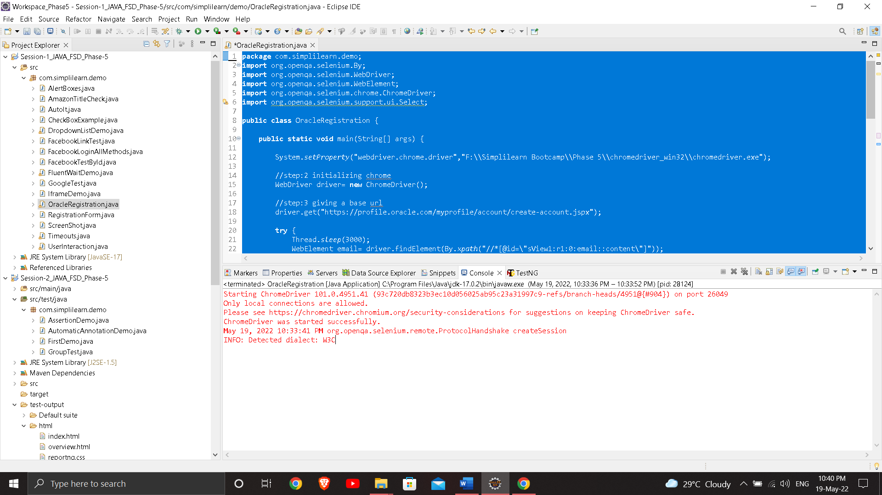

**Output:**

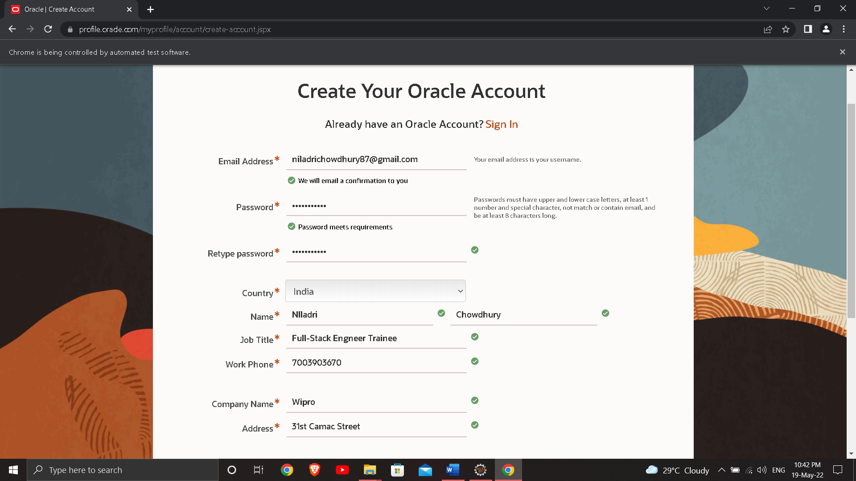

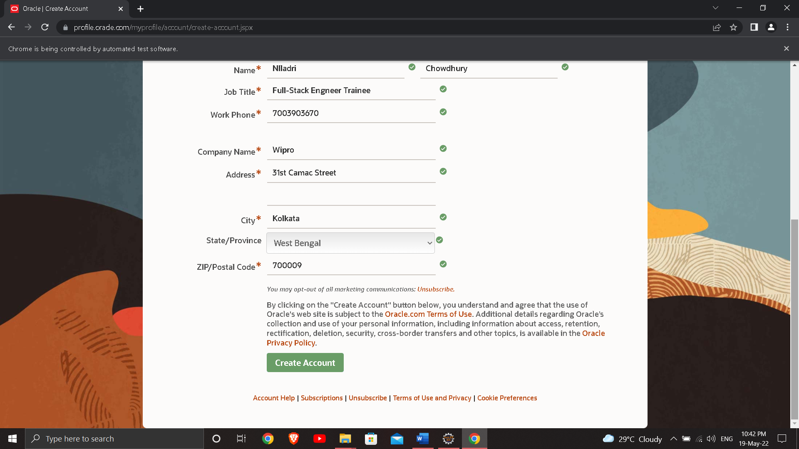

**Selection of Create Account button:**

